PRODUCT REQUIREMENTS DOCUMENT
Lightweight CI/CD Platform
Jenkins-Inspired Build Automation System
Version 1.0 • Engineering Draft
Document Status | Draft — For Internal Review
Version | 1.0
Audience | Engineering, DevOps, Product
Classification | Internal
Authors | Kartikeya Gupta, Dimple Hirwani

1. Executive Summary
This document defines the product requirements for a Lightweight CI/CD Platform, a Jenkins-inspired continuous integration and continuous delivery system designed for small engineering teams and DevOps learners. The platform automates the lifecycle from code commit to build artifact, replacing fragile manual processes with a reliable, repeatable pipeline engine.

Modern software teams face an acute challenge: every code change must be validated, built, tested, and packaged before it can be safely deployed. Without automation, this process is slow, error-prone, and impossible to scale. CI/CD systems solve this by detecting code events and executing a defined sequence of steps in an isolated, reproducible environment.

Target Users
- Small development teams (2 engineers) requiring lightweight build automation
- DevOps practitioners building or studying CI/CD infrastructure
- Engineering educators and bootcamps teaching software delivery concepts
- Startups seeking a self-hosted alternative to expensive SaaS CI platforms

Key Goals
- Automate build, test, and packaging workflows triggered by version control events
- Provide a pipeline-as-code model using YAML configuration stored in repositories
- Execute all jobs in containerized, ephemeral environments for isolation and reproducibility
- Deliver real-time log streaming and structured build result reporting
- Support horizontal scaling of worker nodes to handle concurrent pipeline loads

2. Objectives
The platform must achieve the following engineering objectives in its first production release:

2.1 Automated Build Pipelines
The system must support multi-stage pipelines defined declaratively in YAML. Each stage executes a shell command or script within a container. Stages execute sequentially by default, with failure in any stage halting the pipeline.

2.2 Git Event Triggers
Builds must be automatically triggered via webhook callbacks from Git hosting providers such as GitHub, GitLab, or Gitea. The system must verify webhook signatures, parse the event payload, resolve the target branch and commit SHA, and enqueue a new build within 500ms of receiving the event.

2.3 Containerized Job Execution
Every pipeline job must run in an ephemeral Docker container. The container image is specified in the pipeline YAML and is pulled fresh (or from cache) per execution. No state persists between jobs unless explicitly mounted as a volume. Resource limits (CPU, memory) are enforced per container.

2.4 Pipeline Configuration as Code
Pipeline definitions live in the repository as a .cicd.yml file. This enables versioned, reviewable, and auditable pipeline changes through the same pull request workflow developers already use for application code.

2.5 Real-Time Log Streaming
Clients connected to the build log endpoint must receive a live stream of stdout/stderr output as the pipeline executes. Log lines must be delivered with sub-second latency using Server-Sent Events (SSE) or WebSockets.

2.6 Build Result Reporting
Every completed build must record a structured result containing status (success, failure, cancelled), duration, exit codes per stage, and a link to stored artifacts. Results must be queryable via REST API and displayed in the web dashboard.

2.7 Horizontal Worker Scaling
The worker tier must be stateless and horizontally scalable. Additional worker processes can be added to any machine with network access to the job queue, without any configuration changes to the CI Controller.

3. Non-Goals (Version 1.0)
The following features are explicitly out of scope for the initial release. They are documented here to establish clear boundaries and prevent scope creep during development.

These features may be considered for future versions. See Section 15: Future Enhancements for prioritized candidates.

- Enterprise Role-Based Access Control (RBAC) — fine-grained permissions, audit trails, and SSO/SAML integration
- Kubernetes-native runner integration (KubeRunner) — scheduling pods as build agents
- Plugin/extension marketplace — third-party integrations installable via a registry
- Parallel stage execution within a single pipeline — all stages are sequential in v1
- Dependency caching — no cross-build npm/pip/maven cache sharing in v1
- Multi-tenancy — the system serves a single organization; no tenant isolation
- Native mobile app for build monitoring
- SLA-based build queue prioritization
- Self-hosted Git server — the platform integrates with existing providers only

4. Key Features

4.1 Repository Integration
The platform connects to Git repositories via webhook endpoints. When a developer pushes code or opens a pull request, the Git provider sends an HTTP POST to the CI system’s webhook URL. The system validates the HMAC-SHA256 signature, parses the event, and identifies the affected branch and commit.
- Supports GitHub, GitLab, and Gitea webhook formats
- Verifies webhook secret signatures to prevent spoofed events
- Filters events by branch pattern (e.g., main, release/*)
- Stores raw webhook payloads for auditability

4.2 Pipeline as Code
All pipeline logic is defined in a .cicd.yml file at the repository root. The file specifies the container image, environment variables, and the sequence of named stages to execute. This file is parsed fresh on every build, ensuring pipeline configuration is always consistent with the commit being built.

pipeline:
image: node:18-alpine
environment:
NODE_ENV: test
CI: 'true'
stages:
- name: install
run: npm ci
- name: lint
run: npm run lint
- name: test
run: npm test -- --coverage
- name: build
run: npm run build
- name: docker-build
run: docker build -t myapp:${COMMIT_SHA} .

4.3 Job Queue
Build jobs are placed on an asynchronous queue implemented with Redis. The queue decouples the CI Controller (which receives webhooks) from the Worker Nodes (which execute pipelines). This architecture ensures that a spike in build events does not cause webhook timeouts, and that the system degrades gracefully under load.
- FIFO queue with configurable depth limit (default: 1000 jobs)
- Dead-letter queue (DLQ) for jobs that fail to be claimed after a timeout
- Job payload includes: repository URL, commit SHA, branch, pipeline YAML, and metadata

4.4 Worker Executors
Worker nodes are independent processes that poll the job queue, claim a job, and execute the pipeline inside a Docker container. Workers are stateless and can run on any machine with Docker and network access to the queue. Multiple workers can run concurrently on the same host or across multiple hosts.
- Workers register themselves with a heartbeat every 10 seconds
- A job is re-queued if the claiming worker stops sending heartbeats
- Workers enforce CPU and memory limits via Docker --cpus and --memory flags

4.5 Build Logs
Container stdout and stderr are captured in real time using the Docker logs streaming API. Log lines are written to the Log Storage backend (append-only) and simultaneously pushed to connected clients via Server-Sent Events. Each log line is tagged with a timestamp, stage name, and stream type (stdout/stderr).

4.6 Build Status
Every build has a lifecycle status: pending, running, success, failure, cancelled. Status transitions are atomic and persisted to PostgreSQL. The CI Controller exposes status via REST API and (in future) via commit status callbacks to the Git provider.

4.7 Artifact Storage
Build outputs declared in the pipeline YAML are uploaded to an S3-compatible object store (MinIO for self-hosted deployments). Each artifact is keyed by repository ID, build ID, and filename. Artifacts are retained for a configurable period (default: 30 days) before automated cleanup.

5. System Architecture
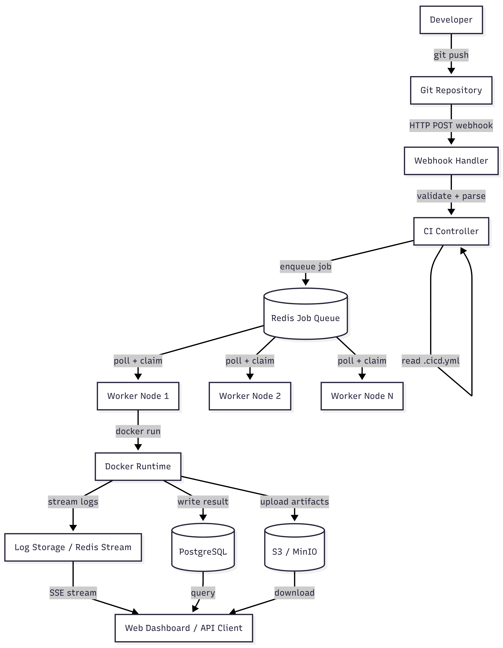

5.1 Component Overview
- CI Controller — Stateless web service; handles webhooks, parses pipeline YAML, creates build records, and enqueues jobs
- Job Queue — Redis-backed FIFO queue; decouples event ingestion from execution; provides job visibility and DLQ
- Worker Nodes — Stateless polling services; claim jobs, launch containers, stream logs, report results
- Execution Environment — Docker daemon; provides container isolation, resource enforcement, and filesystem cleanup
- PostgreSQL Database — Source of truth for all build metadata, status, and results
- Log Storage — Redis Streams (hot) + S3 (cold archival); append-only, indexed by build and stage
- Artifact Storage — S3-compatible object store; versioned by build ID
- Web Dashboard — Read-only React UI consuming the REST API; displays build history, live logs, and artifacts

6. Data Flow Diagram
The following diagram traces the path of a single code push event through the entire system, from developer action to stored result.

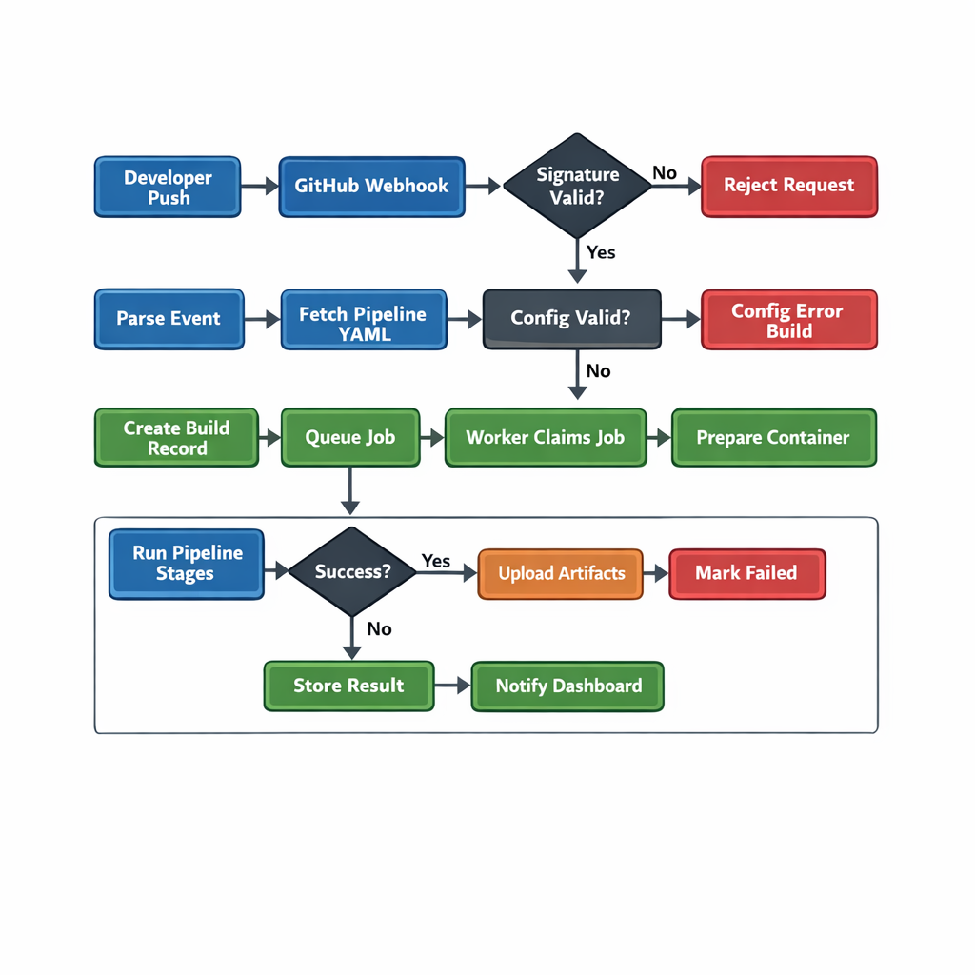

Key design decisions reflected in this flow:
- Webhook validation occurs before any database write, protecting against denial-of-service via forged events
- Pipeline YAML is fetched at the exact commit SHA being built, ensuring the pipeline definition matches the code
- Artifact upload happens before the final result write, so a failed upload marks the build as failed
- The completion event via Redis pub/sub allows the dashboard to update without polling

7. Component Breakdown

7.1 CI Controller
The CI Controller is a stateless HTTP service (Node.js or Python/FastAPI) responsible for the ingestion and orchestration layer.

Responsibilities
- Expose POST /webhook to receive events from Git providers
- Validate HMAC-SHA256 signatures using a per-repository secret
- Fetch the .cicd.yml file via the Git provider’s raw content API at the target commit SHA
- Parse and validate the YAML against the pipeline schema
- Create a Build record in PostgreSQL with status = pending
- Serialize the job payload (repo URL, commit SHA, branch, parsed pipeline, build ID) as JSON
- Push the job to the Redis FIFO queue
- Return HTTP 202 Accepted to the webhook caller

The CI Controller never executes pipeline code. All build logic is delegated to Worker Nodes via the queue. This separation ensures that webhook handling remains fast and never blocked by long-running builds.

7.2 Scheduler
The Scheduler is a lightweight background process embedded within the CI Controller that manages job lifecycle and worker health.

Responsibilities
- Monitor the job queue depth and emit metrics (queue_depth gauge)
- Track worker heartbeats in Redis with a TTL of 30 seconds
- Detect workers that have missed heartbeats and mark their in-progress jobs as orphaned
- Re-enqueue orphaned jobs up to 3 retry attempts before moving them to the DLQ
- Enforce global concurrency limits (max concurrent builds configurable via environment variable)

7.3 Worker Service
The Worker Service is a stateless polling daemon written in the same language as the CI Controller. Multiple instances can run concurrently without coordination.

Responsibilities
- Poll the Redis job queue using BRPOPLPUSH with a 30-second timeout (reliable queue pattern)
- Claim a job by moving it from the pending list to an in-progress list atomically
- Update the Build record status to running in PostgreSQL
- Send heartbeat updates to Redis every 10 seconds while executing
- Invoke the Execution Engine to run the pipeline stages
- Stream log lines to the Log Service as they arrive from Docker
- Upload artifacts on successful completion
- Write the final Build result (status, duration, per-stage exit codes) to PostgreSQL
- Acknowledge (delete) the job from the in-progress list on completion

7.4 Execution Engine
The Execution Engine is the core library embedded within the Worker that directly interacts with the Docker daemon.

Responsibilities
- Pull the specified container image (with exponential backoff on transient failures)
- Create a container with environment variables, resource limits, and a mounted workspace volume
- Execute pipeline stages sequentially by running docker exec for each stage command
- Capture stdout and stderr in real time using the Docker Attach API
- Detect non-zero exit codes and halt execution immediately (fail-fast semantics)
- Remove the container and clean up the workspace volume on completion or failure
- Enforce a per-build timeout (default: 30 minutes); kill the container if exceeded

8. Pipeline Execution Model
Pipelines are declared in .cicd.yml at the repository root. The schema is minimal by design, following the principle of convention over configuration.

8.1 Full Pipeline Schema
# .cicd.yml
pipeline:
image: node:18-alpine # Docker image for all stages
timeout: 1800 # Max build duration in seconds (default: 1800)
environment: # Injected into all stage containers
NODE_ENV: test
DATABASE_URL: postgres://...
secrets: # References to secrets stored in the CI system
- NPM_TOKEN # Injected as env vars, never logged
- DOCKER_PASSWORD
stages:
- name: install
run: npm ci
- name: lint
run: npm run lint
- name: test
run: npm test -- --coverage --reporter=junit
- name: build
run: npm run build
- name: publish
run: docker build -t myapp:${COMMIT_SHA} . && docker push myapp:${COMMIT_SHA}
when: branch == 'main' # Conditional execution
artifacts:
paths:
- dist/
- coverage/lcov.info
expire_in: 30d

8.2 Stage Execution Logic
Stages execute sequentially in the order defined. Each stage runs as a separate shell command within the same container instance (using docker exec), preserving the filesystem state between stages. This is intentional: installed dependencies from the install stage are available in the test stage.

- If a stage exits with code 0: mark stage as passed, continue to next stage
- If a stage exits with non-zero code: mark stage as failed, mark build as failed, stop execution
- If the build timeout is exceeded: send SIGTERM to container, wait 10 seconds, then SIGKILL
- Secrets referenced in the YAML are injected as environment variables and suppressed in log output
- The COMMIT_SHA, BRANCH_NAME, BUILD_ID, and REPO_NAME variables are always injected

8.3 Conditional Execution
The when field on a stage supports simple expressions evaluated by the CI Controller before enqueueing. Supported conditions include branch equality checks (branch == 'main') and tag pattern matches (tag =~ /^v\d+/). Stages whose conditions evaluate to false are skipped and marked as skipped in the build result.

9. Database Design
PostgreSQL is the primary datastore. All tables use UUID primary keys. Timestamps are stored in UTC as timestamptz. Indexes are defined to support the most common query patterns.

9.1 repositories
Field | Type | Description
id | UUID PK | Unique repository identifier
provider | VARCHAR(32) | git_provider: github, gitlab, gitea
full_name | VARCHAR(255) | org/repo-name as returned by provider
clone_url | TEXT | HTTPS clone URL
webhook_secret | TEXT (encrypted) | HMAC secret for webhook validation
default_branch | VARCHAR(128) | Default branch name (e.g. main)
created_at | TIMESTAMPTZ | Record creation timestamp

9.2 builds
Field | Type | Description
id | UUID PK | Unique build identifier
repository_id | UUID FK | References repositories.id
commit_sha | CHAR(40) | Full Git commit SHA
branch | VARCHAR(255) | Source branch name
status | VARCHAR(32) | pending | running | success | failure | cancelled
triggered_by | VARCHAR(64) | push | pull_request | manual | schedule
started_at | TIMESTAMPTZ | When the worker began execution
finished_at | TIMESTAMPTZ | When execution completed or was cancelled
duration_ms | INTEGER | Total execution time in milliseconds
pipeline_yaml | TEXT | Snapshot of pipeline config at time of build
created_at | TIMESTAMPTZ | Record creation timestamp

9.3 stages
Field | Type | Description
id | UUID PK | Unique stage result identifier
build_id | UUID FK | References builds.id
name | VARCHAR(128) | Stage name from pipeline YAML
position | INTEGER | Execution order (0-indexed)
status | VARCHAR(32) | pending | running | success | failure | skipped
exit_code | INTEGER | Container process exit code (null if skipped)
started_at | TIMESTAMPTZ | Stage start timestamp
finished_at | TIMESTAMPTZ | Stage end timestamp
duration_ms | INTEGER | Stage execution time in milliseconds

9.4 artifacts
Field | Type | Description
id | UUID PK | Unique artifact identifier
build_id | UUID FK | References builds.id
name | VARCHAR(255) | Original file or directory path
storage_key | TEXT | S3 object key
size_bytes | BIGINT | File size in bytes
content_type | VARCHAR(128) | MIME type
expires_at | TIMESTAMPTZ | Scheduled deletion timestamp
created_at | TIMESTAMPTZ | Upload timestamp

10. API Design
All endpoints return JSON. Authentication uses Bearer tokens (API keys stored in the database). Rate limiting is applied at 100 requests/minute per token.

POST /webhook
Receives inbound webhook events from Git providers.
Headers:
X-Hub-Signature-256: sha256=<hmac>
X-GitHub-Event: push

Body (GitHub push event):
{
"ref": "refs/heads/main",
"after": "a3f8c2d...",
"repository": { "full_name": "org/repo", "clone_url": "..." }
}

Response 202:
{ "build_id": "uuid", "status": "pending" }

GET /builds
List builds with optional filters.
Query params: repository_id, branch, status, page, limit

Response 200:
{
"builds": [
{ "id": "uuid", "status": "success", "branch": "main",
"commit_sha": "a3f8c2d", "duration_ms": 42300,
"created_at": "2025-03-01T12:00:00Z" }
],
"pagination": { "page": 1, "limit": 20, "total": 84 }
}

GET /builds/{id}
Retrieve full detail for a single build including stage results.
Response 200:
{
"id": "uuid",
"status": "failure",
"stages": [
{ "name": "install", "status": "success", "duration_ms": 8200 },
{ "name": "test", "status": "failure", "exit_code": 1, "duration_ms": 3100 }
],
"artifacts": []
}

GET /builds/{id}/logs
Stream build logs using Server-Sent Events. Each event is a JSON-encoded log line.
Headers:
Accept: text/event-stream

Response (streaming):
data: {"ts":"2025-03-01T12:01:00.123Z","stage":"test","stream":"stdout","line":"PASS src/app.test.js"}
data: {"ts":"2025-03-01T12:01:00.456Z","stage":"test","stream":"stderr","line":"Error: Cannot find module"}
data: {"event":"build.complete","status":"failure"}

POST /builds/{id}/cancel
Cancel a pending or running build. Sends SIGTERM to the running container.
Response 200:
{ "id": "uuid", "status": "cancelled" }

GET /builds/{id}/artifacts
List artifacts for a completed build with pre-signed download URLs.
Response 200:
{
"artifacts": [
{ "name": "dist/app.js", "size_bytes": 142300,
"download_url": "https://storage.../presigned?token=...",
"expires_at": "2025-04-01T00:00:00Z" }
]
}

11. Worker Execution Model

11.1 Job Polling
Workers use the Redis BRPOPLPUSH command to atomically move a job from the pending queue to an in-progress queue. This reliable queue pattern ensures that if a worker crashes mid-execution, the Scheduler can detect the orphaned job and re-enqueue it. Workers block with a 30-second timeout, then loop, maintaining a low-latency polling behavior without busy-waiting.

11.2 Container Execution
docker run \
--rm \
--name cicd-build-{build_id} \
--cpus="1.0" \
--memory="512m" \
--memory-swap="512m" \
--network=none \
--env COMMIT_SHA={sha} \
--env BRANCH_NAME={branch} \
--env BUILD_ID={id} \
--env-file /tmp/secrets-{id}.env \
--volume /workspace/{id}:/workspace \
--workdir /workspace \
{image}

11.3 Resource Limits
Default resource limits are configurable per deployment and can be overridden in the pipeline YAML:
- CPU: 1.0 core (configurable, max 4.0)
- Memory: 512 MB (configurable, max 4 GB)
- Disk (workspace): 2 GB ephemeral volume
- Build timeout: 30 minutes (configurable up to 2 hours)
- Network: disabled by default; enabled only if pipeline requests it

11.4 Environment Setup
Before container execution, the Worker performs the following setup steps:
- Creates an ephemeral workspace directory on the host
- Clones the repository at the exact commit SHA into the workspace
- Resolves referenced secrets from the secrets store and writes them to a temporary env file (mode 0600)
- Deletes the env file immediately after docker run exits to prevent credential leakage

12. Security Considerations

12.1 Running Untrusted Code
Pipeline YAML may contain arbitrary shell commands submitted by repository contributors. The system must treat all pipeline code as untrusted:
- All execution occurs inside Docker containers with no host filesystem access
- Network access is disabled by default; pipelines must explicitly request it
- Container processes run as a non-root user (uid 1000) by default
- The Docker daemon socket is never mounted into build containers
- Host directories are not accessible from inside build containers

12.2 Webhook Authentication
- Every repository has a unique HMAC-SHA256 webhook secret
- Signature validation uses constant-time comparison to prevent timing attacks
- Webhook payloads are rejected immediately if signature is absent or invalid
- Raw webhook payloads are logged for forensic analysis

12.3 Secret Management
- Secrets are stored encrypted at rest using AES-256-GCM with a KMS-managed key
- Secrets are injected as environment variables at runtime; they are never written to logs
- Log scrubbing: the log pipeline replaces known secret values with [REDACTED]
- Secrets are stored in a temporary file (mode 0600) that is deleted immediately after use

12.4 Rate Limiting
- Webhook endpoint: 100 requests/minute per repository
- REST API: 100 requests/minute per API key
- Build trigger rate: configurable max builds per hour per repository
- Queue depth limit: 1000 pending jobs (configurable); new jobs rejected beyond this limit

13. Scalability Considerations

13.1 Horizontal Worker Scaling
The worker tier is designed to scale horizontally with zero configuration. Additional workers are launched as processes or containers pointed at the same Redis queue. The queue’s BRPOPLPUSH command provides natural load balancing: whichever worker is free first claims the next job.

Scaling guidance:
- 1 worker: suitable for teams with < 5 daily builds
- 3–5 workers: suitable for teams with 20–50 daily builds and short build times
- 10+ workers: suitable for larger teams or repositories with > 5 minute builds

13.2 Distributed Queue
Redis is deployed in a primary-replica configuration with Redis Sentinel for automatic failover. The job queue is backed by Redis persistence (AOF with fsync everysec) to prevent job loss during restarts. For very high throughput, the queue can be migrated to a dedicated message broker such as RabbitMQ or Apache Kafka without changes to the Worker interface.

13.3 Database Scaling
PostgreSQL is deployed with a read replica for analytics and dashboard queries. Write traffic (build results, log metadata) remains on the primary. Connection pooling is handled by PgBouncer in transaction mode, supporting hundreds of concurrent worker connections with a small number of actual database connections.

13.4 Artifact Storage Scaling
Artifact storage on S3 scales horizontally without application-level changes. For self-hosted deployments using MinIO, a distributed MinIO cluster (4+ nodes) can be configured to handle multi-terabyte artifact storage with 99.999% durability. Pre-signed URLs allow clients to download artifacts directly from S3, bypassing the CI Controller and preventing it from becoming a bandwidth bottleneck.

14. Observability

14.1 Logging
All services emit structured JSON logs to stdout. Log fields include: service, level, timestamp (ISO 8601), request_id (for tracing across services), and context-specific fields. Logs are collected by a log aggregator (Loki, Datadog, or CloudWatch) and indexed for search.

- Info: webhook received, build enqueued, stage started/completed, artifact uploaded
- Warning: job retry attempted, worker heartbeat missed, queue depth above 80%
- Error: webhook signature failure, Docker pull failure, database write failure

14.2 Metrics
The CI Controller and Worker services expose Prometheus metrics on /metrics:
- builds_total (counter): total builds by status and repository
- build_duration_seconds (histogram): build execution time distribution
- queue_depth (gauge): current number of pending jobs in the queue
- worker_count (gauge): number of active (heartbeating) workers
- stage_failure_rate (gauge): ratio of failed stages per repository

14.3 Alerting
Recommended alert thresholds for production deployments:
- Queue depth > 100 for more than 5 minutes: indicates insufficient worker capacity
- Worker count == 0: no workers active; all builds will stall
- Build failure rate > 50% in a 1-hour window: potential infrastructure issue
- Webhook endpoint p99 latency > 500ms: indicates CI Controller overload

15. Future Enhancements
The following features are candidates for future versions, ordered by estimated impact and development effort:

15.1 Parallel Stage Execution
Allow pipeline stages to declare dependencies and execute concurrently where the dependency graph permits. This requires a DAG execution engine in the Worker and significant changes to the log streaming model.

15.2 Dependency Caching
Mount a shared cache volume per repository that persists node_modules, .gradle, or pip caches across builds on the same worker. Implement a cache key based on a hash of dependency manifests (package-lock.json, requirements.txt) to invalidate stale caches.

15.3 Kubernetes Runners
Implement a Kubernetes-native worker that schedules each build job as a Kubernetes Pod. This enables resource-efficient bin-packing across a cluster, native integration with Kubernetes secrets, and auto-scaling via the Horizontal Pod Autoscaler.

15.4 Pull Request Status Reporting
After a build completes, post a commit status back to the Git provider’s API (GitHub Checks API, GitLab Commit Status API). This enables blocking pull request merges on failed CI builds directly within the Git provider’s interface.

15.5 Pipeline Visualization UI
A React-based dashboard providing: a build history timeline, live log streaming with stage navigation, artifact download, and pipeline YAML validation with a visual stage graph. The UI consumes the REST API and SSE endpoints defined in this PRD.

15.6 Plugin System
A plugin architecture allowing third-party integrations (Slack notifications, JIRA ticket linking, SonarQube code quality gates) to hook into build lifecycle events. Plugins would be declared in the pipeline YAML and distributed via a registry.

Appendix A: Technology Stack

Component | Technology | Rationale
CI Controller | Node.js / Fastify | High throughput HTTP, non-blocking I/O
Worker Service | Node.js / Python | Docker SDK availability, async I/O
Job Queue | Redis 7+ | BRPOPLPUSH, Streams, pub/sub in one service
Database | PostgreSQL 15+ | ACID, JSON support, mature ORM ecosystem
Container Runtime | Docker Engine | Ubiquitous, well-documented API
Artifact Storage | MinIO / AWS S3 | S3-compatible; self-hosted or cloud
Log Aggregation | Redis Streams + S3 | Hot path streaming + cold archival
Metrics | Prometheus + Grafana | Industry standard; vendor-neutral
Frontend | React + TypeScript | Component ecosystem; SSE support

End of Document
Lightweight CI/CD Platform PRD • Version 1.0

